Inglés. 2º Primaria Repaso Primer Trimestre.

Nombre: ________________________________

My face.

Write the missing days of the week in the correct place.
Friday– Tuesday - Sunday- Wednesday

Monday Thursday
Saturday

Inglés. 2º Primaria Repaso Primer Trimestre.
Nombre: ________________________________
Read the sentences and color the picture
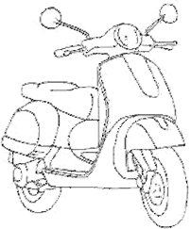

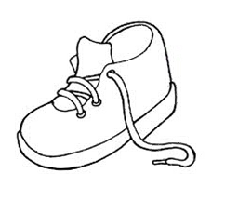
- The | motorbike is red. |  | - The | umbrella is blue.
- The | duck is brown. |  | - The | table is orange.
- The | house is green. |  | - The | Windows are purple.
- The | shoe is black |  | - The | door is white.
- The | ball is pink |  | - The | trees are green.
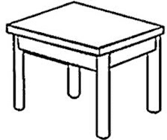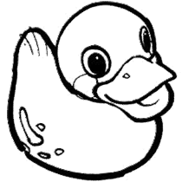

Inglés. 2º Primaria Repaso Primer Trimestre.
Nombre: ________________________________
Write the numbers.




How many?
There are_________________

There _______________________

_____________________________
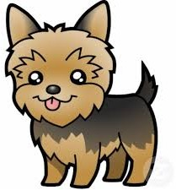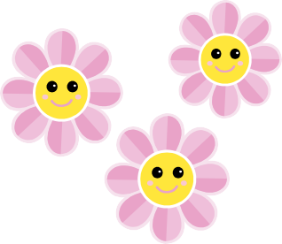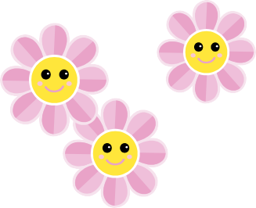

Inglés. 2º Primaria Repaso Primer Trimestre.
Nombre: ________________________________
Label the parts of the body.
e f
h
a
f |  |  | l
Find 5 words in the wordsearch and draw them on the body
M | O | U | T | H | G | F | 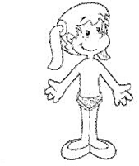
S | D | W | R | G | A | I
D | E | F | U | N | T | N
A | D | E | Q | F | R | G
N | J | E | Z | A | S | E
O | B | T | O | T | H | R
S | R | L | E | A | R | S
E | F | D | S | U | N | C
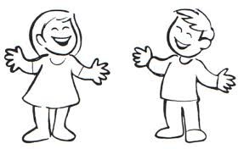

Inglés. 2º Primaria Repaso Primer Trimestre.
Nombre: ________________________________
Match the activity with the place
I play computer games.

I swim.

I ride my bicycle. I watch TV.
I play football.

I sleep.

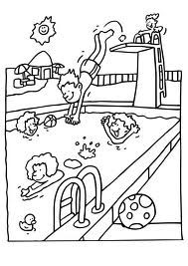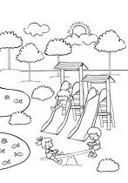

Inglés. 2º Primaria Repaso Primer Trimestre.
Nombre: ________________________________
Look at the picture and write: true (t) or false (f)
The rabbit´s eyes are small. The rabbit´s ears are short. The rabbit´s tail is hard.
The rabbit´s mouth is small. The rabbit´s legs are long.
Correct the wrong sentences and write them correctly.
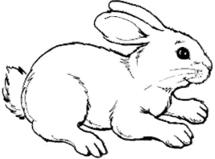

Inglés. 2º Primaria Repaso Primer Trimestre.
Nombre: ________________________________
Draw and color
Read and circle the correct Word.
What´s it? What´s it?

It´s a house/school It´s a byke/car
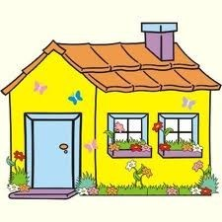

Two blue houses | Five red tomatoes | A brown dog

Ten green pears | Four yellow cars | Twelve pink flowers

Inglés. 2º Primaria | Repaso Primer Trimestre.
Nombre: ________________________________
Write the correct Word.
I with my ears.
 | See.
I with my mouth. | Hear.
 | Taste.
I with my nose. | Smell.
I with my eyes.
Read and circle the correct Word.
What´s it?  It´s a cat/dog | What´s it?  It´s a rabbit /mouse
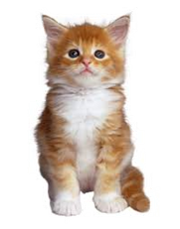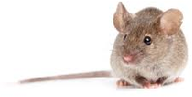

Inglés. 2º Primaria Repaso Primer Trimestre.
Nombre: ________________________________
Find the words
MUM DAD BROTHER SISTER AUNT UNCLE
GRANDMA GRANDDAD SON DAUGHTER
Read and circle the correct Word.
What´s this? What´s this?

this is a girl/ boy this is a dog /mouse

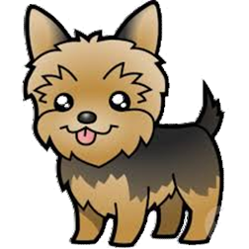
M | U | M | B | C | G | F | V | B | S
G | R | A | N | D | D | A | D | H | I
D | E | A | U | N | T | U | L | N | S
A | D | W | Q | F | R | P | M | N | T
D | J | M | Z | A | S | O | N | R | E
J | B | R | O | T | H | E | R | E | R
G | R | A | N | D | M | A | E | W | E
G | F | D | S | U | N | C | L | E | A
R | D | A | U | G | H | T | E | R | M
S | D | J | F | E | P | Y | J | W | N

Inglés. 2º Primaria Repaso Primer Trimestre.
Nombre: ________________________________
Write the words
gegs  atrew
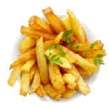 shcip tebutr
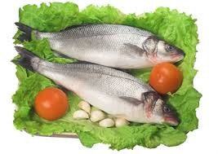 fhis kociose
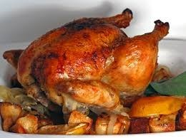 hckein negroa
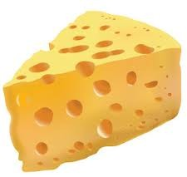 echesse crie
pelap 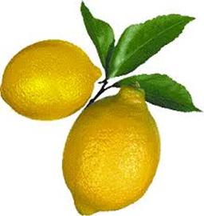 melon
abnnaa dnacy
ebdar 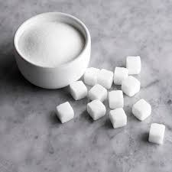 gasur
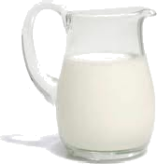 lmik
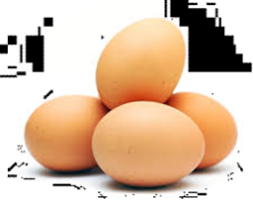
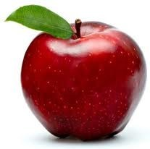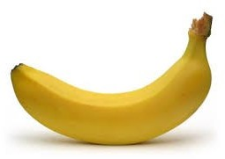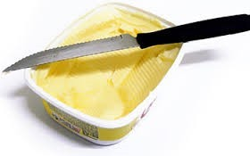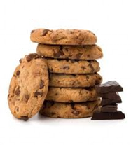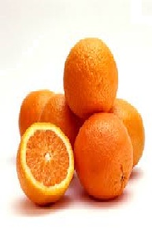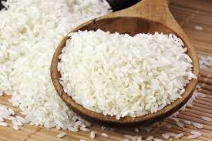

Inglés. 2º Primaria | Repaso Primer Trimestre.
Nombre: ________________________________
Write and match the seasons.
verano |  | otoño
invierno | primavera
Read and draw.
2 green eyes.
1 red mouth.
1 orange nose.
-Brown hair
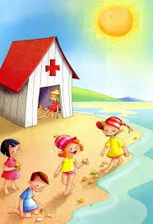
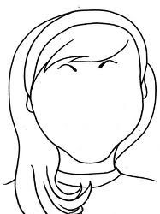
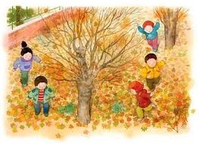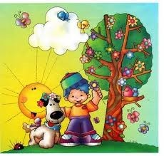

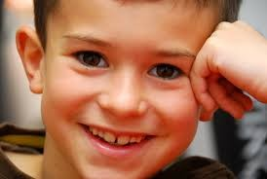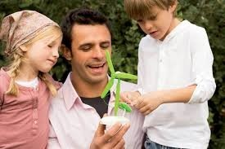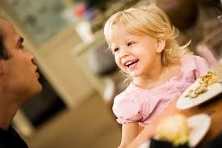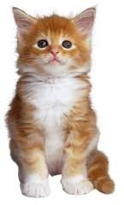Inglés. 2º Primaria Repaso Primer Trimestre.

Nombre: ________________________________

Complete with am, is, are.

She happy.

I six years old.

We friends.

He my father.

You in the house.

It beauty.

They happy.

Inglés. 2º Primaria Repaso Primer Trimestre.
Nombre: ________________________________
Write It is …… or It is not……
What´s it? It is not an apple.
It is a banana.

What´s it? a dog.
a cat.

What´s it? a house.
a school.

What´s it? an eye.
a nose.

What´s it? a car.
a lorry.
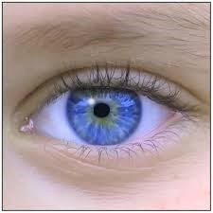


Inglés. 2º Primaria Repaso Primer Trimestre.
Nombre: ________________________________
Find the words
MONDAY TUESDAY WEDNESDAY THURSDAY FRIDAY SATURDAY SUNDAY
How many?
There are eight apples.

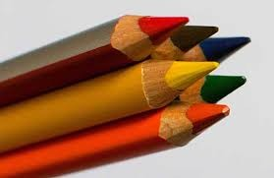
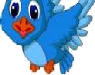
S | W | E | D | N | E | S | D | A | Y
A | S | A | N | D | D | A | D | H | I
T | U | E | D | M | O | N | D | A | Y
U | N | W | Q | F | R | P | M | N | T
R | D | M | Z | A | S | O | N | R | E
D | A | T | U | E | S | D | A | Y | R
A | Y | A | N | F | R | I | D | A | Y
M | T | A | R | S | J | S | V | C | R
Y | T | H | U | R | S | D | A | Y | A
F | E | R | M | A | L | R | R | S | L

Inglés. 2º Primaria Repaso Primer Trimestre.
Nombre: ________________________________
Observe and complete.
Grandfather Grandmother
Peter Mary
Father Mother aunt uncle
Paul Ann Rachel John

Linda George Jim Jenny Sarah

I AM JIM. • Rachel is my _ .
- Linda is my sister. • John is my .
- George is my . • Sarah is my .
- Ann is my . • Sarah is Rachel´s
- Paul is my . • George is Peter´s .
- is my grandfat- • Jenny is
her. grandaughter.
- Mary is my .
- Jenny is my .
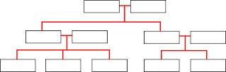

Inglés. 2º Primaria Repaso Primer Trimestre.
Nombre: ________________________________
Match the word´s halves and draw a weather symbol.
Win- | -ny
Sno -ny
Sun- -dy
Ray -wy
Write the words
Jumper skirt trousers T-shirt dress

1 2 3 4 5
1.  2.  3. |  | 4.  5.
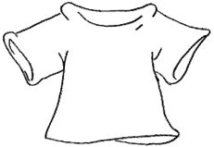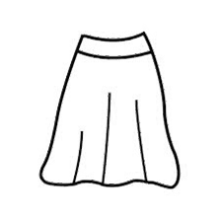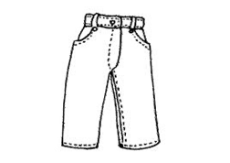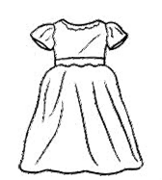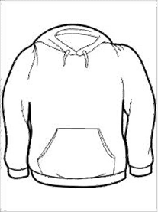

Inglés. 2º Primaria Repaso Primer Trimestre.
Nombre: ________________________________
Write It is …… or It is not……
What´s it? It is not a foot.
It is a hand.

What´s it?
an eye.
a mouth.

What´s it?
a horse.
a lion.

What´s it? a cat.
a dog.
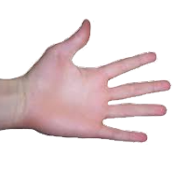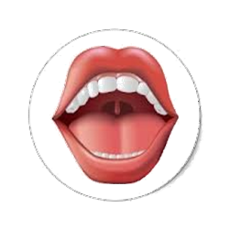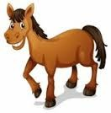

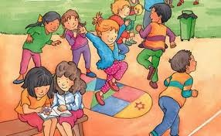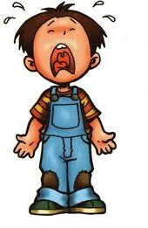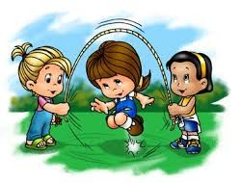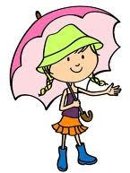Inglés. 2º Primaria Repaso Primer Trimestre.

Nombre: ________________________________

Complete with am, is, are.

They in the park.

You sad.

We happy.

She my sister.

It a dog.

He Danny.

I in the street.

Inglés. 2º Primaria Repaso Primer Trimestre.
Nombre: ________________________________
Write the name
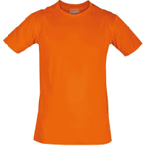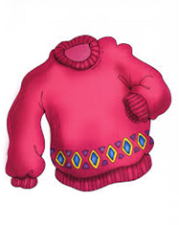

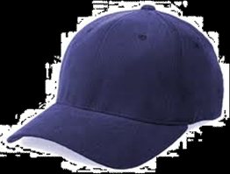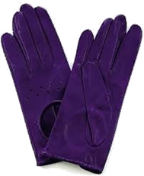
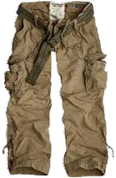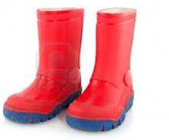
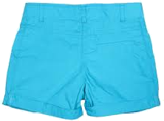
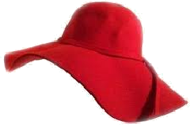

Inglés. 2º Primaria |  |  | Repaso Primer Trimestre.
Nombre: ________________________________
Read, draw and color.
Write the word
Sunny | snowy | windy | rainy  

A blue skirt. | A red boots. | A green cap.

A yellow hat. | A pink dress. | A black trousers.

