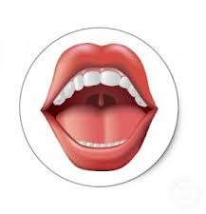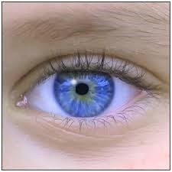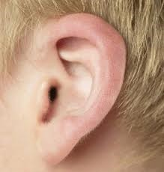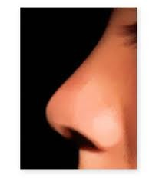Inglés. 2º Primaria Repaso Segundo Trimestre.

Nombre: ________________________________

Math each word with the suitable picture

Ojo : eye

Nariz: nose

Orejas: Ears

Cara: Face

Boca: Mouth

Write the missing days of the week in the correct place.
Friday– Tuesday - Sunday- Wednesday

Monday Thursday
Saturday

Inglés. 2º Primaria Repaso Segundo Trimestre.
Nombre: ________________________________
Saludos. Copia los saludos
Hola: Hello
Buenos días: Good morning.
¿Qué tal estas?: How are you?
Yo estoy bien ¿y tú?: I´m fine and you
¿Cuántos años tienes?: How old are you?
Yo tengo 8 años : I´m 8 yeras old
Adios: Bye bye
Completa el dialogo, con las expresiones de arriba.
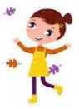

Inglés. 2º Primaria Repaso Primer Trimestre.
Nombre: ________________________________
Write the numbers.




How many?
There are_________________

There _______________________

_____________________________


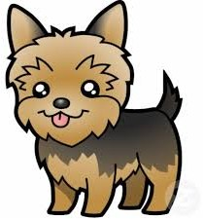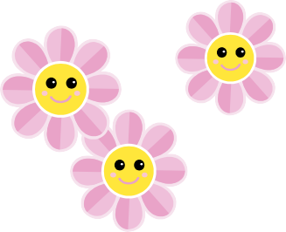

Inglés. 2º Primaria Repaso Segundo Trimestre.
Nombre: ________________________________
Verbo To be. Completa el verbo to be
I am
You are
He is
She is
It is
We are
You are
They are
Complete with to be (am , is , are) and translate
She Ann.

He _________ my father

We friends.




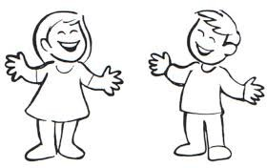Inglés. 2º Primaria Repaso Segundo Trimestre.

Nombre: ________________________________

Read and draw the body part.

Hands (manos) | Feet (pies) | Eyes. (ojos)

Legs (piernas) | Arms (brazos) | Head (cabeza)

Label the parts of the body.

e
h

h
a

f
l

Inglés. 2º Primaria Repaso Segundo Trimestre.
Nombre: ________________________________
Look at the picture and write: true (t) or false (f)
The rabbit´s eyes are small. The rabbit´s ears are short. The rabbit´s tail is hard.
The rabbit´s mouth is small. The rabbit´s legs are long.
Correct the wrong sentences and write them correctly.
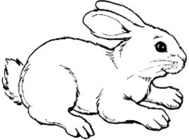

Inglés. 2º Primaria Repaso Segundo Trimestre.
Nombre: ________________________________
The negative form of the verb be. Completa la forma ne- gativa del verbo to be
I _______ _____ am not
You ________ ______ are not
He ________ _____ is not
She _______ _____ is not
It _________ ____ is not
We ________ _____ are not
You ________ _____ are not
They _________ ____ are not
Read and circle the correct Word.
What´s it? What´s it?

It´s a house/school It´s a byke/car
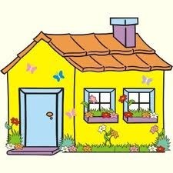


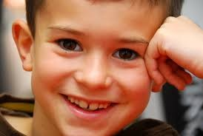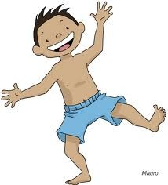Inglés. 2º Primaria Repaso Segundo Trimestre.

Nombre: ________________________________

Complete with to be (am , is , are) and translate

You Peter.

She angry.

I happy.

Escribe la forma negativa de las oraciones anteriores.

Inglés. 2º Primaria Repaso Segundo Trimestre.
Nombre: ________________________________
Find the |  | words
MUM DAD BROTHER SISTER AUNT UNCLE
GRANDMA GRANDDAD SON DAUGHTER
 | Write the family
Papá |  |  | Abuela
Mamá |  |  | Tío
Hija |  |  | Tía
Hijo |  |  | Hermano
Abuelo |  |  | Hermana
M | U | M | B | C | G | F | V | B | S
G | R | A | N | D | D | A | D | H | I
D | E | A | U | N | T | U | L | N | S
A | D | W | Q | F | R | P | M | N | T
D | J | M | Z | A | S | O | N | R | E
J | B | R | O | T | H | E | R | E | R
G | R | A | N | D | M | A | E | W | E
G | F | D | S | U | N | C | L | E | A
R | D | A | U | G | H | T | E | R | M
S | D | J | F | E | P | Y | J | W | N

Inglés. 2º Primaria Repaso Segundo Trimestre.
Nombre: ________________________________
Find |  | the | words
ONE (1)
TWO (2)
THREE (3)
FOUR (4)
FIVE (5)
SIX (6)
SEVEN (7)
EIGHT (8)
NINE (9)
TEN (10)
 | Write the numbers
1 |  |  |  | 6
2 |  |  |  | 7
3 |  |  |  | 8
4 |  |  |  | 9
5 |  |  |  | 10
M | S | E | F | S | E | V | E | N | S
G | R | O | O | E | D | A | D | H | I
D | E | A | U | N | T | U | L | N | X
E | I | G | H | T | R | P | M | N | T
D | J | M | Z | A | S | O | N | E | W
T | H | R | E | E | H | E | R | E | O
G | R | N | I | N | E | A | E | W | E
T | E | N | S | U | F | I | V | E | A

Inglés. 2º Primaria Repaso Segundo Trimestre.
Nombre: ________________________________
Write the negative form of the sentences
AFFIRMATIVE | NEGATIVE
He is tall.
It is cute.
I am nine years old.
He is Chinese.
They are funny.
You are intelligent.
We are friends.
He is Richard.
She is my sister.
You are a teacher.

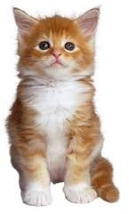Inglés. 2º Primaria Repaso Segundo Trimestre.

Nombre: ________________________________

Complete with verb be and write the negative form

She happy.

I six years old.

We friends.

He my father.

You in the house.

It beauty.

They happy.

Inglés. 2º Primaria Repaso Segundo Trimestre.
Nombre: ________________________________
Write the afirmative form of the sentences
AFFIRMATIVE | NEGATIVE
 | She is not fat.
 | I am not six years old.
 | It is not red.
 | We are not in home.
 | He is not Peter.
 | They are not Spanish.
 | You are not tall.
 | He is not my brother.
 | You are not friends.
 | We are not family.

Inglés. 2º Primaria | Repaso Segundo Trimestre.
Nombre: ________________________________
Find the words
 |  | MONDAY TUESDAY WEDNESDAY THURSDAY FRIDAY SATURDAY SUNDAY
Write the days of the week
Lunes | Viernes
Martes | Sábado
Miércoles | Domingo
Jueves
S | W | E | D | N | E | S | D | A | Y
A | S | A | N | D | D | A | D | H | I
T | U | E | D | M | O | N | D | A | Y
U | N | W | Q | F | R | P | M | N | T
R | D | M | Z | A | S | O | N | R | E
D | A | T | U | E | S | D | A | Y | R
A | Y | A | N | F | R | I | D | A | Y
M | T | A | R | S | J | S | V | C | R
Y | T | H | U | R | S | D | A | Y | A
F | E | R | M | A | L | R | R | S | L

To Have Got. Tener

I have got You have got. He has got She has got
It has got We have got
You have got They have got
I _______
You ________
He ________
She _______
It _________
We ________
You ________
They _________
_____ have got
______ have got
_____ has got
_____ has got
____ has got
_____ have got
_____ have got
____ have got

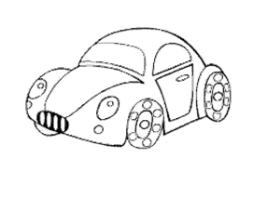
Complete with to have (have got or has got) and traslate

I____________________ two cats.

She _________ a pencil.

We_________ three dogs.

They________ a car.

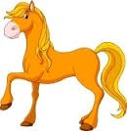Complete with(has got, have got), and translate

They a ball.

She an orange juice

It a pencil

I an umbrella.

He a house.

You a telephone.

She a horse.

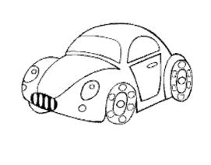
To Have Got negative form.
I have not got You have not got. He has not got She has not got
It has not got We have not got
You have not got They have not got
I _______
You ________
He ________
She _______
It _________
We ________
You ________
They _________
_____ have not got
______ have not got
_____ has not got
_____ has not got
____ has not got
_____ have not got
_____ have not got
____ have not got
Complete with to have in negative form

I____________________ two cats.

She _________ a pencil.

We_________ three dogs.

They________ a car.

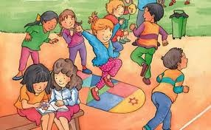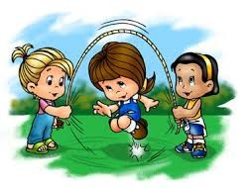
Complete with am, is, are. And translate

They in the park.

You sad.

We happy.

She my sister.

It a dog.

He Danny.

I in the street.

Escribe la forma negativa del verbo to have got y tradu- ce.
They a ball.

She an orange juice

It a pencil

I an umbrella.

He a house.

You a telephone.

She a horse.

Inglés. 2º Primaria |  |  | Repaso Segundo Trimestre.
Nombre: ________________________________
Read, draw and color.
Write the word
Sunny | snowy | windy | rainy  


A blue skirt. | A red boots. | A green cap.

A yellow hat. | A pink dress. | A black trousers.

