Inglés. 3º Primaria Repaso Primer Trimestre.
Nombre: ________________________________
Days of the week. Read and complete.
Today is Monday. Yesterday was Tomorrow will be .
Today is Friday. Yesterday was Tomorrow will be .
Today is Wednesday. Yesterday was Tomorrow will be .
Today is Saturday. Yesterday was Tomorrow will be .
Write the negative form of the sentences.
I play football.
I like chocolate.
You are happy.

Inglés. 3º Primaria Repaso Primer Trimestre.

Nombre: ________________________________

My face

Write the interrogative form of the sentences
I play football.
I like chocolate.

You are happy.

Inglés. 3º Primaria Repaso Primer Trimestre.
Nombre: ________________________________
Look at the pictures and complete the sentences.
 | y   | Tuesday
Saturday
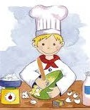

On Friday he . they dance.

they play tenis. he cooks.

they go to the cinema.

On Wednesday .

On Monday they .
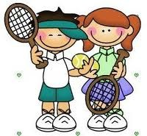
Monday |  |  | Wednesday |  |  | Frida
 | Sunday |  |  |  | Thursday

Inglés. 3º Primaria Repaso Primer Trimestre.
Nombre: ________________________________
Write the numbers.




How many?
There are_________________

____________________________

_____________________________
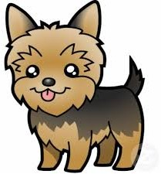

Inglés. 3º Primaria |  | Repaso Primer Trimestre.
Nombre: ________________________________
Directions. Where is the school?
restaurant school
school |  | hotel
Indica como ir al parque.
You are here park | park  You are here
restaurant | school |  | park

Inglés. 3º Primaria |  | Repaso Primer Trimestre.
Nombre: ________________________________
Write a/an /or nothing.
cat. | apple. |  | plain.
tomatoe. | door. |  | elephant.
dogs. | ant. |  | person.
man. | chairs. |  | map.
hat. | university. |  | bananas.
women | island. |  | friends.
Write the negative form of the sentences.
She is Ann.
We have got a book
You play tenis
She has got a dog

Inglés. 3º Primaria Repaso Primer Trimestre.
Nombre: ________________________________
Look at the picture and write: true (t) or false (f)
The rabbit´s eyes are small. The rabbit´s ears are short. The rabbit´s tail is hard.
The rabbit´s mouth is small. The rabbit´s legs are long.
Correct wrong sentences and write them correctly.
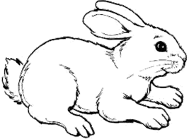

Inglés. 3º Primaria Repaso Primer Trimestre.
Nombre: ________________________________
Draw and color
Write the interrogative form of the sentences.
She is Ann.
We have got a book
You play tenis
She has got a dog
Two blue houses | Five red tomatoes | A brown dog

Ten green pears | Four yellow cars | Twelve pink flowers

Inglés. 3º Primaria |  | Repaso Primer Trimestre.
Nombre: ________________________________
Choose and write.
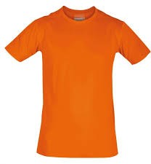 | blue red orange | Cap  hat t-shirt boots
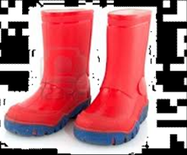

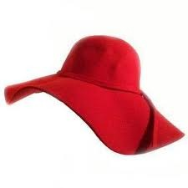

—-
a
an

Inglés. 3º Primaria | Repaso Primer Trimestre.
Nombre: ________________________________
Find the words
MUM DAD BROTHER SISTER AUNT UNCLE
GRANDMA GRANDDAD SON DAUGHTER
Answer the questions.
What´s this? | What´s this?

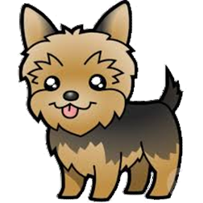
M | U | M | B | C | G | F | V | B | S
G | R | A | N | D | D | A | D | H | I
D | E | A | U | N | T | U | L | N | S
A | D | W | Q | F | R | P | M | N | T
D | J | M | Z | A | S | O | N | R | E
J | B | R | O | T | H | E | R | E | R
G | R | A | N | D | M | A | E | W | E
G | F | D | S | U | N | C | L | E | A
R | D | A | U | G | H | T | E | R | M
S | D | J | F | E | P | Y | J | W | N

Inglés. 3º Primaria Repaso Primer Trimestre.
Nombre: ________________________________
Write the words
gegs  atrew
 shcip tebutr
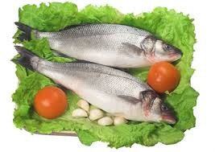 fhis kociose
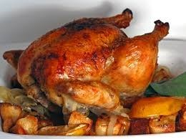 hckein negroa
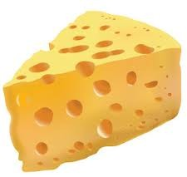 echesse crie
pelap 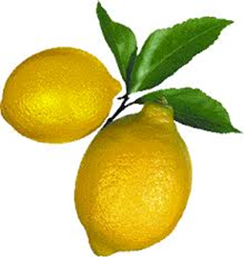 melon
abnnaa dnacy
ebdar 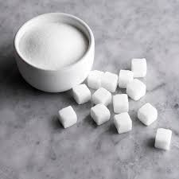 gasur
 lmik
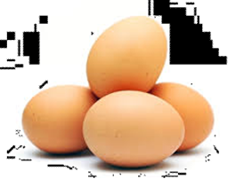
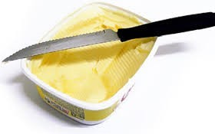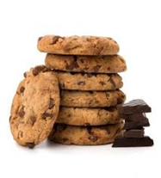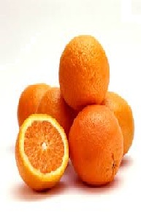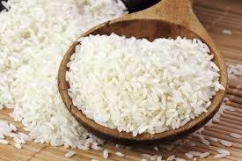

Inglés. 3º Primaria Repaso Primer Trimestre.
Nombre: ________________________________
Write the questions-
They can dance well.
Can they dance well?
He can play guitar.

She can speak spanish.

He can ride a bicycle.

They can play basketball.
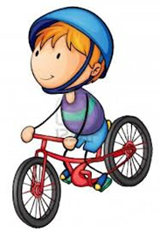

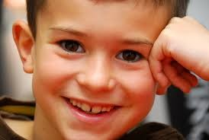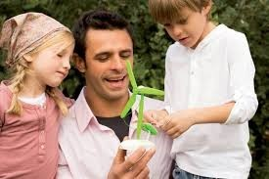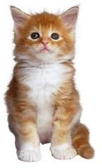Inglés. 3º Primaria Repaso Primer Trimestre.

Nombre: ________________________________

Complete with am, is, are, and write the negative form.

She happy.

I six years old.

We friends.

He my father.

You in the house.

It beauty.

They happy.

Inglés. 3º Primaria Repaso Primer Trimestre.
Nombre: ________________________________
Write I can / I can´t 
Ride bicycle.


Run.


swim


Play guitar


Ride a horse




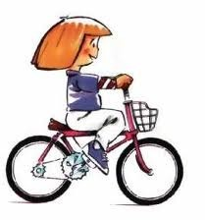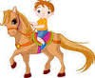

Inglés. 3º Primaria Repaso Primer Trimestre.
Nombre: ________________________________
Find the words
MONDAY TUESDAY WEDNESDAY THURSDAY FRIDAY SATURDAY SUNDAY
How many?
There are eight apples.



S | W | E | D | N | E | S | D | A | Y
A | S | A | N | D | D | A | D | H | I
T | U | E | D | M | O | N | D | A | Y
U | N | W | Q | F | R | P | M | N | T
R | D | M | Z | A | S | O | N | R | E
D | A | T | U | E | S | D | A | Y | R
A | Y | A | N | F | R | I | D | A | Y
M | T | A | R | S | J | S | V | C | R
Y | T | H | U | R | S | D | A | Y | A
F | E | R | M | A | L | R | R | S | L

Inglés. 3º Primaria Repaso Primer Trimestre.
Nombre: ________________________________
Observe and complete.
Grandfather Grandmother
Peter Mary
Father Mother aunt uncle
Paul Ann Rachel John

Linda George Jim Jenny Sarah
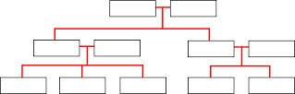
I AM JIM.  - Linda is my sister.  - George is my .  - Ann is my .  - Paul is my .  - is my grandfather.  - Mary is my .  - Jenny is my . |  | - Rachel is my _ .  - John is my .  - Sarah is my .  - Sarah is Rachel´s  - George is Peter´s .  - Jenny is  grandaughter.

Inglés. 3º Primaria Repaso Primer Trimestre.
Nombre: ________________________________
Ordena las palabras y escribe oraciones.
can´t |  | german | I | speak
a | got have |  | You | book
piano | play you |  | can
can  my | well she  She is |  | sing  friend

Inglés. 3º Primaria Repaso Primer Trimestre.
Nombre: ________________________________
Where is the flower?
The flower is on the table.

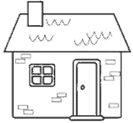

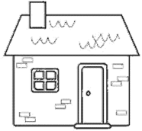

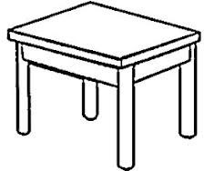

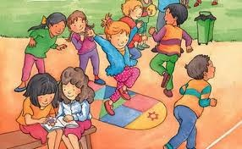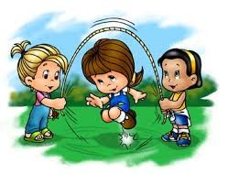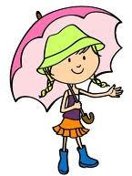Inglés. 3º Primaria Repaso Primer Trimestre.

Nombre: ________________________________

Complete with am, is, are, and write the negative form.

They in the park.

You sad.

We happy.

She my sister.

It a dog.

He Danny.

I in the street.

Inglés. 3º Primaria Repaso Primer Trimestre.
Nombre: ________________________________
What are they doing?
What is she doing?
She is a book.

What are they doing? They are basket.

What is he doing?

What are they doing?
