Inglés. 1º Primaria Repaso Primer Trimestre.
Nombre: ________________________________
Color according to the instructions .
RED GREEN
BLUE  YELLOW
 ORANGE PINK
Count and write the number



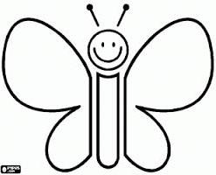

Inglés. 1º Primaria Repaso Primer Trimestre.
Nombre: ________________________________
Read the sentences and color the picture
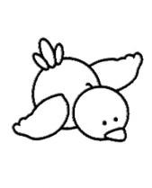

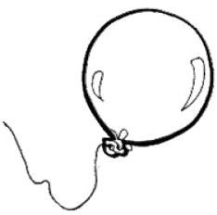

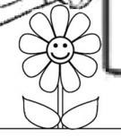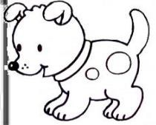
- The | car is red. |  | - The | cloud is blue.
- The | dog is brown. |  | - The | bird is orange.
- The | house is green. |  | - The | flower is pink.
- The | cat is black |  | - The | sun is yellow.
- The | balloon is pink
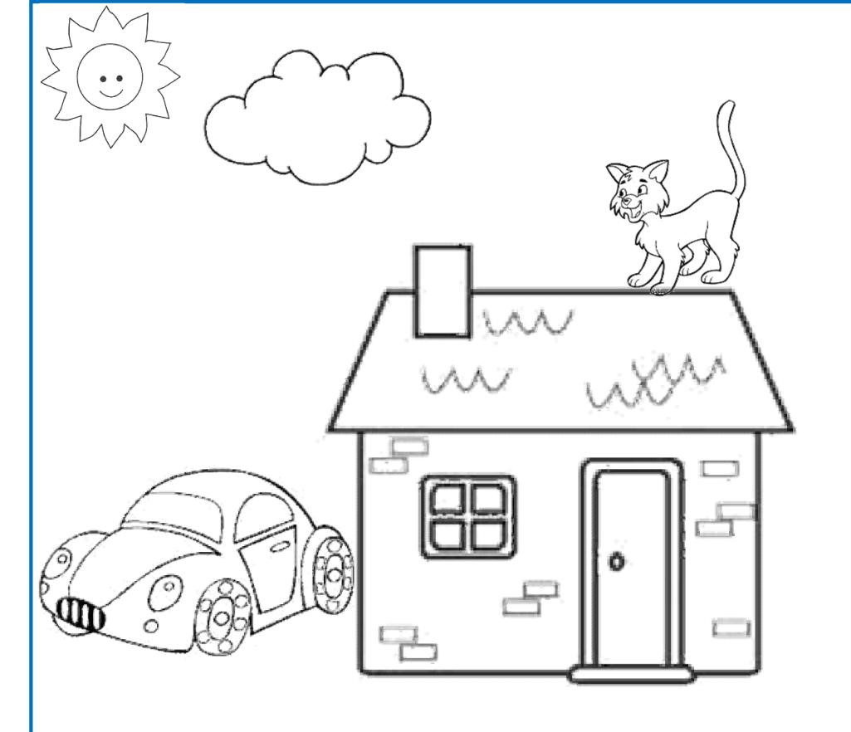

Inglés. 1º Primaria Repaso Primer Trimestre.
Nombre: ________________________________
Match the numbers.

How many?
Four pencils
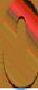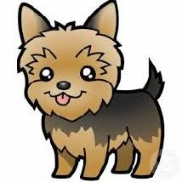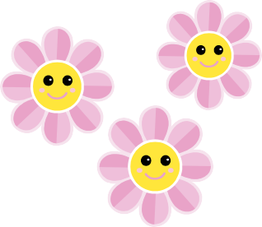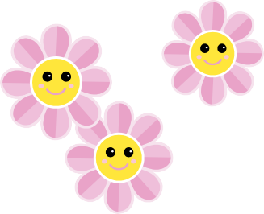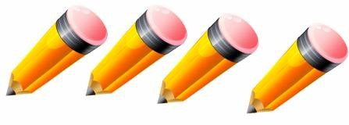

Inglés. 1º Primaria Repaso Primer Trimestre.
Nombre: ________________________________
Read and draw the face.
I am sad I am happy
Write the missing days of the week in the correct place.
Friday– Tuesday - Sunday- Wednesday
Monday |  |  | Thursday
Saturday
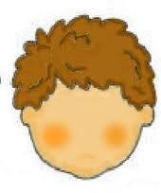

Inglés. 1º Primaria Repaso Primer Trimestre.
Nombre: ________________________________
Match the activity with the place
I play computer games.

I swim.

I ride my bicycle. I watch TV.
I play football.

I sleep.

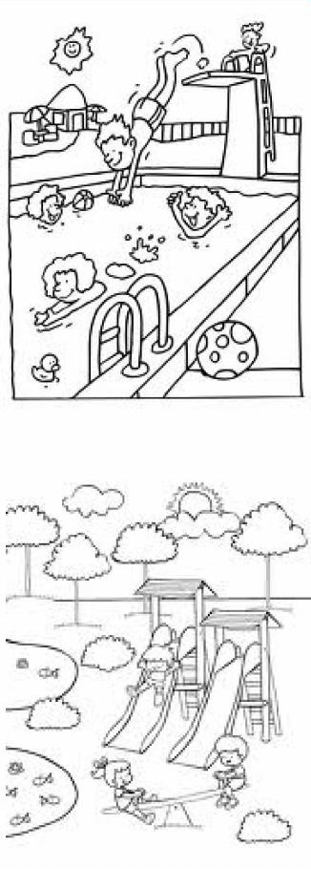

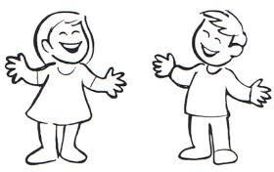Inglés. 1º Primaria Repaso Primer Trimestre.

Nombre: ________________________________

Read and draw the parts of the body .

hands | Feet. | Eyes.

legs | arms | heart

Label the parts of the body.

e
f

h
a

f
l

Inglés. 1º Primaria Repaso Primer Trimestre.
Nombre: ________________________________
Draw and color
Read and circle the correct Word.
What´s this? What´s this?

this is a hand/mouth this is an eye /nose
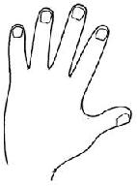
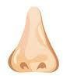
A blue house | A red tomatoe | A brown dog

A green pear | A yellow car | A pink flower

Inglés. 1º Primaria Repaso Primer Trimestre.
Nombre: ________________________________
Write the correct Word.
I hear with my ………………………
 | Eyes
I taste with my……………………… | Ears
 | Mouth
I smell with my……………………… | Nose
I see with my………………………
Read and circle the correct Word.
What´s this? What´s this?

this is a cat/dog this is a rabit /mouse
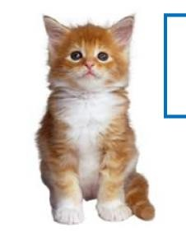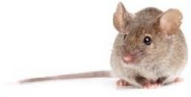

Inglés. 1º Primaria Repaso Primer Trimestre.
Nombre: ________________________________
Find the words
MUM DAD BROTHER SISTER AUNT UNCLE
GRANDMA GRANDDAD SON
Read and circle the correct Word.
What´s this? What´s this?

this is a girl/ boy this is a dog /mouse

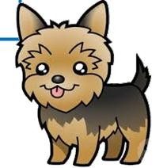
M | U | M | B | C | G | F | V | B | S
G | R | A | N | D | D | A | D | H | I
D | E | A | U | N | T | U | L | N | S
A | D | W | Q | F | R | P | M | N | T
D | J | M | Z | A | S | O | N | R | E
J | B | R | O | T | H | E | R | E | R
G | R | A | N | D | M | A | E | W | E
G | F | D | S | U | N | C | L | E | A

Inglés. 1º Primaria Repaso Primer Trimestre.
Nombre: ________________________________
Write the words
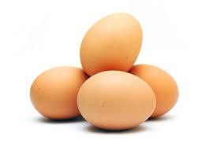 gegs shcip

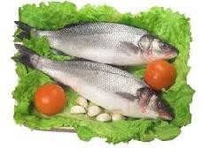 fhis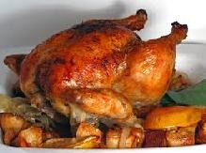 hckeinc
echesse

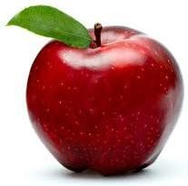 pelap
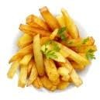
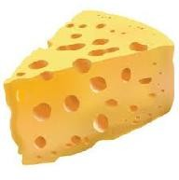

Inglés. 1º Primaria Repaso Primer Trimestre.
Nombre: ________________________________
Match
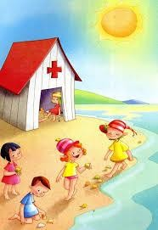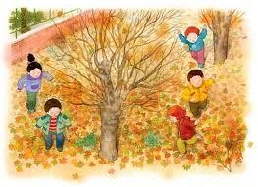

Summer Autumn Spring Winter verano otoño primavera invierno

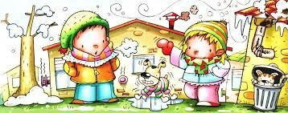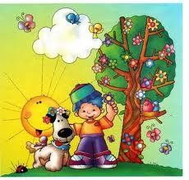

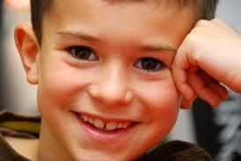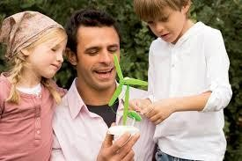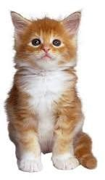Inglés. 1º Primaria Repaso Primer Trimestre.

Nombre: ________________________________

Complete with verb be

She happy.

I six years old.

We friends.

He my father.

You in the house.

It beauty.

They happy.

Inglés. 1º Primaria Repaso Primer Trimestre.
Nombre: ________________________________
Write : It is … or It is not……
What´s it? It is not an apple.
It is a banana.

What´s it?
a dog.
a cat.

What´s it?
a house.
a school.

What´s it? an eye.
a nose.

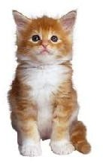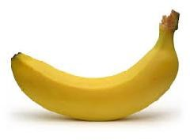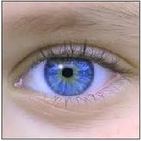

Inglés. 1º Primaria Repaso Primer Trimestre.
Nombre: ________________________________
Find the words
MONDAY TUESDAY WEDNESDAY THURSDAY FRIDAY SATURDAY SUNDAY
How many?
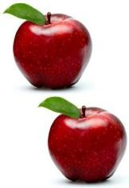 eight apples.

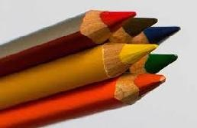
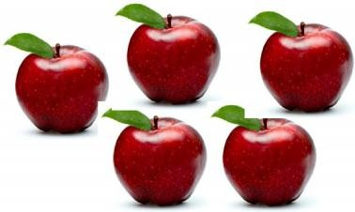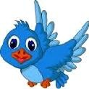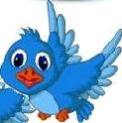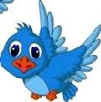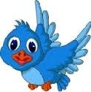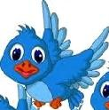
S | W | E | D | N | E | S | D | A | Y
A | S | A | N | D | D | A | D | H | I
T | U | E | D | M | O | N | D | A | Y
U | N | W | Q | F | R | P | M | N | T
R | D | M | Z | A | S | O | N | R | E
D | A | T | U | E | S | D | A | Y | R
A | Y | A | N | F | R | I | D | A | Y
Y | T | H | U | R | S | D | A | Y | A

Inglés. 1º Primaria Repaso Primer Trimestre.
Nombre: ________________________________
Observe and complete.
Grandfather Grandmother
Peter Mary
Father Mother
Paul Ann FAMILY
Linda George Jim I AM JIM.
- Linda is my sister.
- George is my .
- Ann is my .
- Paul is my .
- is my grandfather.
- Mary is my .
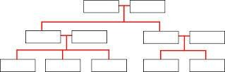
Rachel John

Jenny Sarah

Inglés. 1º Primaria Repaso Primer Trimestre.
Nombre: ________________________________
Read and draw.
2 green eyes.
1 red mouth.
1 orange nose.
Complete with the colour.
 The bird is blue.
 The car is .
The house .

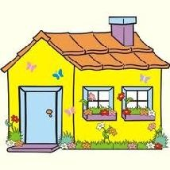

Inglés. 1º Primaria Repaso Primer Trimestre.
Nombre: ________________________________
Write : It is …… or It is not……
What´s it? It is not a foot.
It is a hand.

What´s it?
an eye.
a mouth.

What´s it?
a horse.
a lion.

What´s it? a cat.
a dog.
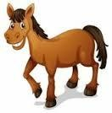
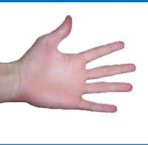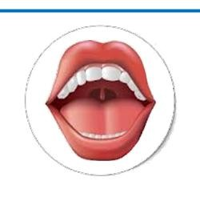

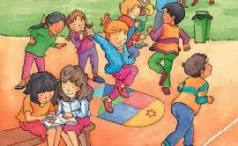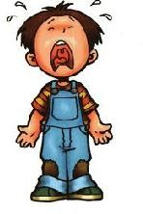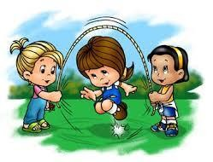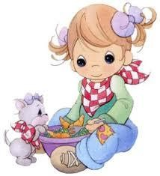Inglés. 1º Primaria Repaso Primer Trimestre.

Nombre: ________________________________

Complete with verb be

They in the park.

You sad.

We happy.

She my sister.

It a dog.

He Danny.

I in the street.

Inglés. 1º Primaria Repaso Primer Trimestre.
Nombre: ________________________________
Coloraccording to the instructions .
RED GREEN
BLUE  YELLOW
 ORANGE PINK
Count and write the number



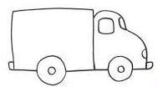

Inglés. 1º Primaria Repaso Primer Trimestre.

Nombre: ________________________________

Read, draw and color.

A blue pencil. | A red Apple. | A green ball.

A yellow sun. | A pink bird. | A black table.

Label the parts of the body.

h
e

m
h

l
n

