Inglés. 1º Primaria Repaso Segundo Trimestre.
Nombre: ________________________________
Math each words with the suitable
Jumper: sudadera Skirt: falda Trousers: pantalones T-shirt: camiseta Dress: Vestido
Hat: Sombrero Cap: Gorra
What are they wearing?
- She is wearing a blue ____________________

- He is wearing a yellow ______________ 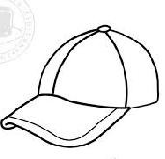
- You are wearing a green __________ 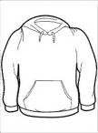
- I am ____________ a red _____________. 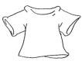
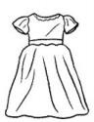
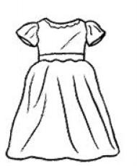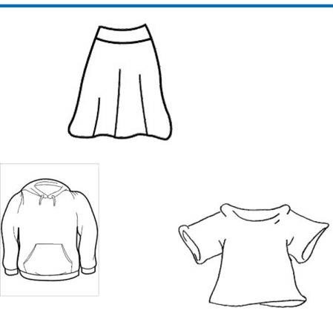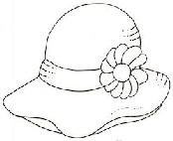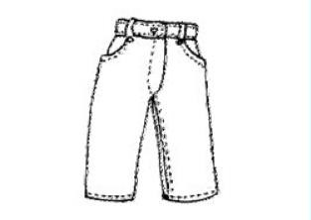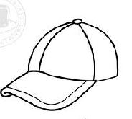

Inglés. 1º Primaria Repaso Segundo Trimestre.
Nombre: ________________________________
Complete the conversation.
Peter Hello!!!! I am _.
What´s your name? Ann

_________. I
_______ Ann
(Hola. Yo soy Peter.
¿Cómo te llamas?)
(Hola. Yo soy Ann)

I´m years old.
How old are you?

I six
______________.
How are you?
(Yo tengo siete años.
¿Cuántos años tienes
tú?) (Yo tengo seis años. ¿Qué
tal estas?)

I´m fine. Thanks you. And you?

(Yo bien , gracias. ¿Y tú?)
(Yo bien, gracias)
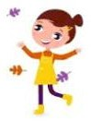
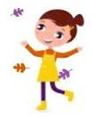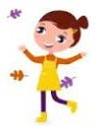

Inglés. 1º Primaria Repaso Segundo Trimestre.
Nombre: ________________________________
Saludos. Copia los saludos
Hola: Hello
Buenos días: Good morning.
¿Qué tal estas?: How are you?
Adios: Bye bye
Verbo To be
I am I am
You are You are
He is He is
She is She is
It is It is
We are We are
You are You are
They are They are

Inglés. 1º Primaria Repaso Segundo Trimestre.
Nombre: ________________________________
Complete with (am , is , are) verb be and translate
She Ann.

He _________ my father

We friends.

It ________ my house.

You Peter.
Write the missing days of the week in the correct place.
Friday– Tuesday - Sunday- Wednesday
Monday |  |  | Thursday
Saturday




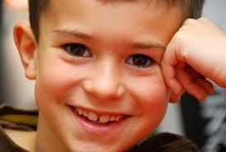

Inglés. 1º Primaria Repaso Segundo Trimestre.
Nombre: ________________________________
Match
Hello | Yo estoy bien.
How are you? |  |  |  | ¿Cuántos años tienes?
Adiós
I am John
Yo tengo seis años
How old are you?
I´m fine Gracias
I´m six years old Yo soy John
Hola
Thanks
Bye |  | ¿Cómo estas?

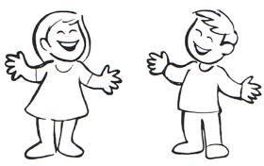Inglés. 1º Primaria Repaso Segundo Trimestre.

Nombre: ________________________________

Read and draw the parts of the body .

Hands (manos) | Feet (pies) | Eyes. (ojos)

Legs (piernas) | Arms (brazos) | Head (cabeza)

Label the parts of the body.

e
h

h
a

f
l

Inglés. 1º Primaria Repaso Segundo Trimestre.
Nombre: ________________________________
Negative form of the verb be
I am not | I _______ | _____ am not
You are not | You ________ | ______ are not
He is not | He ________ | _____ is not
She is not | She _______ | _____ is not
It is not | It _________ | ____ is not
We are not | We ________ | _____ are not
You are not | You ________ | _____ are not
They are not | They _________ | ____ are not
Read and circle the correct Word.
What´s this? What´s this?

this is a hand/mouth this is an eye /nose
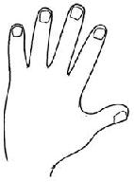
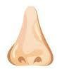

Inglés. 1º Primaria Repaso Segundo Trimestre.
Nombre: ________________________________
Find |  | the | words
ONE (1)
TWO (2)
THREE (3)
FOUR (4)
FIVE (5)
SIX (6)
SEVEN (7)
EIGHT (8)
NINE (9)
TEN (10)
 | Write the numbers
1 |  |  |  | 6
2 |  |  |  | 7
3 |  |  |  | 8
4 |  |  |  | 9
5 |  |  |  | 10
M | S | E | F | S | E | V | E | N | S
G | R | O | O | E | D | A | D | H | I
D | E | A | U | N | T | U | L | N | X
E | I | G | H | T | R | P | M | N | T
D | J | M | Z | A | S | O | N | E | W
T | H | R | E | E | H | E | R | E | O
G | R | N | I | N | E | A | E | W | E
T | E | N | S | U | F | I | V | E | A

Inglés. 1º Primaria Repaso Segundo Trimestre.
Nombre: ________________________________
Find the words
MUM DAD BROTHER SISTER AUNT UNCLE
GRANDMA GRANDDAD SON
Read and circle the correct Word.
What´s this? What´s this?

this is a girl/ boy this is a dog /mouse

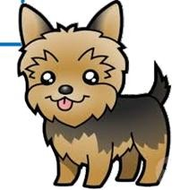
M | U | M | B | C | G | F | V | B | S
G | R | A | N | D | D | A | D | H | I
D | E | A | U | N | T | U | L | N | S
A | D | W | Q | F | R | P | M | N | T
D | J | M | Z | A | S | O | N | R | E
J | B | R | O | T | H | E | R | E | R
G | R | A | N | D | M | A | E | W | E
G | F | D | S | U | N | C | L | E | A

Inglés. 1º Primaria Repaso Segundo Trimestre.
Nombre: ________________________________
Complete with (am , is , are) verb be and translate
It red.
She _________ my sister.

We_________ a family.

They friends.

He Peter.

I happy.
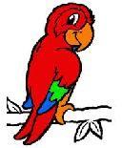
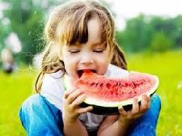



Inglés. 1º Primaria Repaso Segundo Trimestre.
Nombre: ________________________________
Write the negative form of the sentences
AFIRMATIVE | NEGATIVE
It is red.
You are Dann.
I am six years old.
They are Italian.
We are friends.
He is tall.
She is intelligent.
They are family.
We are in class.
He is Peter.

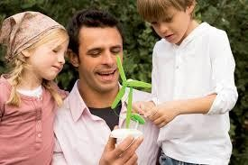Inglés. 1º Primaria Repaso Segundo Trimestre.

Nombre: ________________________________

Complete with (am, is, are) verb be

She happy.

I six years old.

We friends.

He my father.

You in the house.

It beauty.

They happy.

Inglés. 1º Primaria Repaso Segundo Trimestre.
Nombre: ________________________________
Write: It is … or It is not……
What´s it? It is not an apple.
It is a banana.

What´s it?
a dog.
a cat.

What´s it?
a house.
a school.

What´s it? an eye.
a nose.
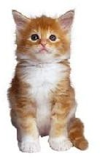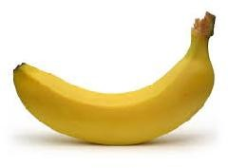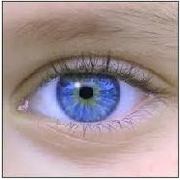

Inglés. 1º Primaria |  | Repaso Segundo Trimestre.
Nombre: ________________________________
Find the words
 |  |  | MONDAY TUESDAY WEDNESDAY THURSDAY FRIDAY SATURDAY SUNDAY
 | Translate the days of the week.
 | Lunes | Sábado
 | Martes | Domingo
 | Miércoles
 | Jueves
 | Viernes
S | W | E | D | N | E | S | D | A | Y
A | S | A | N | D | D | A | D | H | I
T | U | E | D | M | O | N | D | A | Y
U | N | W | Q | F | R | P | M | N | T
R | D | M | Z | A | S | O | N | R | E
D | A | T | U | E | S | D | A | Y | R
A | Y | A | N | F | R | I | D | A | Y
Y | T | H | U | R | S | D | A | Y | A

Inglés. 1º Primaria Repaso Segundo Trimestre. Nombre: ________________________________
To Have Got. Tener
 |  | I have got You have got.  He has got |  |  | I _______  You ________  He ________ |  |  | _____ have got  ______ have got  _____ has got
 |  | She has got It has got We have got  You have got They have got |  |  | She _______  It _________  We ________  You ________  They _________ |  |  | _____ has got  ____ has got  _____ have got  _____ have got  ____ have got
Complete with to have (have got or has got) and translate

I____________________ two cat.



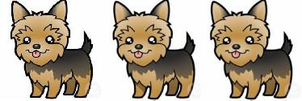She _________ a pencil.

We_________ three dogs.

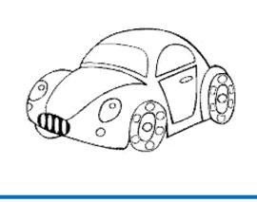
They________ a car.
Ce-
lia Rodríguez Ruiz

Inglés. 1º Primaria Repaso Primer Trimestre.
Nombre: ________________________________
Read and draw.
2 green eyes.
1 red mouth.
1 orange nose.
Complete with the colour.
 The bird is blue.
 The car is .
The house .
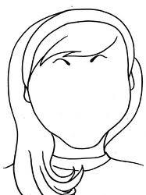
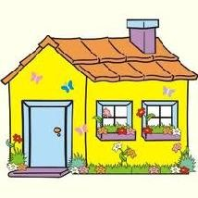

Inglés. 1º Primaria Repaso Segundo Trimestre.
Nombre: ________________________________
Write It is …… or It is not……
What´s it? It is not a foot.
It is a hand.

What´s it?
an eye.
a mouth.

What´s it?
a horse.
a lion.

What´s it? a cat.
a dog.
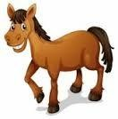
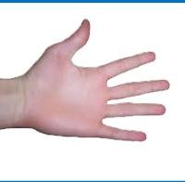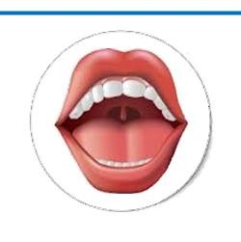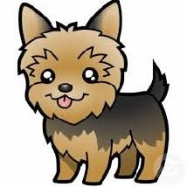

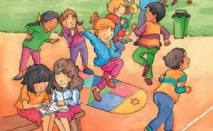Inglés. 1º Primaria Repaso Primer Trimestre.

Nombre: ________________________________
Complete with to have (has got, have got), and transla- te
They friends

You a new t-shirt

She a cat.

I a dog.

He a ball.

You a flower.

She an umbrella

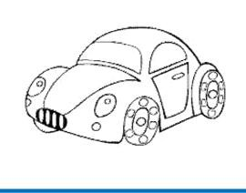Inglés. 1º Primaria Repaso Segundo Trimestre.

Nombre: ________________________________

To Have Got in a negative form.
I have not got You have not got. He has not got She has not got
It has not got We have not got
You have not got They have not got
I _______
You ________
He ________
She _______
It _________
We ________
You ________
They _________
_____ have not got
______ have not got
_____ has not got
_____ has not got
____ has not got
_____ have not got
_____ have not got
____ have not got
Complete with the negative form of the verb “have”

I____________________ two cat.

She _________ a pencil.

We_________ three dogs.

They________ a car.

Inglés. 1º Primaria Repaso Segundo Trimestre.

Nombre: ________________________________

Read, draw and color.

A blue pencil. | A red Apple. | A green ball.

A yellow sun. | A pink bird. | A black table.

Label the parts of the body.

h
e

m
h

l
n

