Inglés. 1º Primaria Repaso Tercer Trimestre.
Nombre: ________________________________
Math each words with the suitable picture
Doll: muñeca Train: tren Car: coche Plane: Avión
Guitar: Guitarra
Drum: Tambor
Ball: Pelota 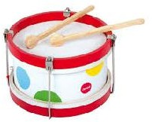 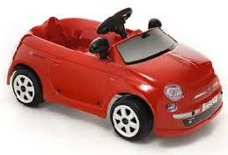
What are they playing?
- She is playing with a________________

- He is playing with a______________

- You are playing with a __________
- I am ____________ with a ___________

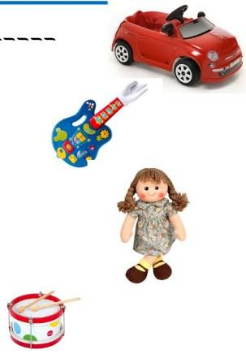
____

Inglés. 1º Primaria Repaso Tercer Trimestre.
Nombre: ________________________________
Complete the conversation.
Peter Hello!!!! I am _.
What´s your name? Ann

_________. I
_______ Ann
(Hola. Yo soy Peter.
¿Cómo te llamas?)
(Hola. Yo soy Ann)

I´m years old.
How old are you?

I six
______________.
How are you?
(Yo tengo siete años.
¿Cuántos años tienes
tú?) (Yo tengo seis años. ¿Qué
tal estas?)

I´m fine. Thanks you. And you?

(Yo bien , gracias. ¿Y tú?)
(Yo bien, gracias)



Inglés. 1º Primaria Repaso Tercer Trimestre.
Nombre: ________________________________
Saludos . Escribelos en inglés
Hola:
Buenos días:
¿Qué tal estas?
Adios:
Verbo To be. Escribe el verbo to be de manera afirmati- va y negativa
AFIRMATIVA NEGATIVA
I _________ _____________
_____________ _____________
He _________ ____________
She ________ ____________
______________ ______________
We __________ ______________
____________ ____________
______________ ______________

Inglés. 1º Primaria Repaso Tercer Trimestre.
Nombre: ________________________________
Complete with negative form of verb be and translate
She Ann.

He _________ my father

We friends.

It ________ my house.

You Peter.
Write the days of the week in the correct place.






Inglés. 1º Primaria Repaso Tercer Trimestre.
Nombre: ________________________________
Match
Hello | Yo estoy bien.
How are you? |  |  |  | ¿Cuántos años tienes?
Adiós
I am John
Yo tengo seis años
How old are you?
I´m fine Gracias
I´m six years old Yo soy John
Hola
Thanks
Bye |  | ¿Cómo estas?

Inglés. 1º Primaria Repaso Tercer Trimestre.

Nombre: ________________________________

Verbo to be. Interrogative form

Am I?
Are you? Is he?
Is she? Is it?
Are we? Are you? Are they?
____ I?
______ you?
________ he?
_______ she?
_______ it?
________we?
________ you?
_______ they?
Am ___? Are ?
Is ?
Is ?
Is ?
Are ?
Are ?
Are ?

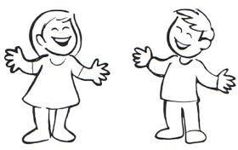

Label the parts of the body.

e h
h
a
f l

Inglés. 1º Primaria Repaso Tercer Trimestre.
Nombre: ________________________________
Completa con la forma interrogativa del verbo to be
___________ you in home?

___________ she happy?

___________ they friends?
Read and answer the questions
What´s this? What´s this?
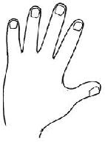


Inglés. 1º Primaria Repaso Tercer Trimestre.
Nombre: ________________________________
Find |  | the | words
ONE (1)
TWO (2)
THREE (3)
FOUR (4)
FIVE (5)
SIX (6)
SEVEN (7)
EIGHT (8)
NINE (9)
TEN (10)
 | Write the numbers
1 |  |  |  | 6
2 |  |  |  | 7
3 |  |  |  | 8
4 |  |  |  | 9
5 |  |  |  | 10
M | S | E | F | S | E | V | E | N | S
G | R | O | O | E | D | A | D | H | I
D | E | A | U | N | T | U | L | N | X
E | I | G | H | T | R | P | M | N | T
D | J | M | Z | A | S | O | N | E | W
T | H | R | E | E | H | E | R | E | O
G | R | N | I | N | E | A | E | W | E
T | E | N | S | U | F | I | V | E | A

Inglés. 1º Primaria | Repaso Tercer Trimestre.
Nombre: ________________________________
Find the words
MUM DAD BROTHER SISTER AUNT UNCLE
GRANDMA GRANDDAD SON
Read and answer the questions
What´s this? | What´s this?

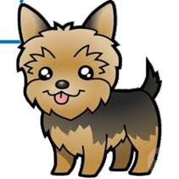
M | U | M | B | C | G | F | V | B | S
G | R | A | N | D | D | A | D | H | I
D | E | A | U | N | T | U | L | N | S
A | D | W | Q | F | R | P | M | N | T
D | J | M | Z | A | S | O | N | R | E
J | B | R | O | T | H | E | R | E | R
G | R | A | N | D | M | A | E | W | E
G | F | D | S | U | N | C | L | E | A

Inglés. 1º Primaria Repaso Tercer Trimestre.
Nombre: ________________________________
Complete with (am , is , are), write the negative and in- terrogative form, and traslate
It red.
She _________ my sister.

We_________ a family.

They friends.

He Peter.

I happy.

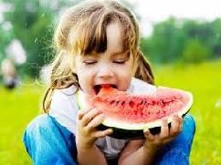



Inglés. 1º Primaria Repaso Tercer Trimestre.
Nombre: ________________________________
Write the negative and interrogative form of the follo- wing sentences
 | AFIRMATIVE | NEGATIVE | INTERROGATIVE
 | It is cute.
 | He is Dann.
 | I am happy.
 | We are chinese.
 | They are friends.
 | She is funny.
 | You are intelligent.
 | We are family.
 | You are in class.
 | He is Peter.

Inglés. 1º Primaria Repaso Tercer Trimestre. Nombre: ________________________________
To Have Got. Tener
 |  | I have got You have got.  He has got |  |  | I _______  You ________  He ________ |  |  | _____ have got  ______ have got  _____ has got
 |  | She has got It has got We have got  You have got They have got |  |  | She _______  It _________  We ________  You ________  They _________ |  |  | _____ has got  ____ has got  _____ have got  _____ have got  ____ have got
 |  | Complete with translate  I_______________    We thr  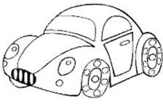 | to have (have g  _____ two cat.  She _________ a pe ee dogs.  They________ |  |  | ot or h  ncil.  a car. |  |  | as got) and  


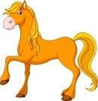Inglés. 1º Primaria Repaso Tercer Trimestre.

Nombre: ________________________________
Complete with to have (has got, have got), and transla- te
They a ball.

She an orange juice

It a pencil

I an umbrella.

He a house.

You a telephone.

She a horse.

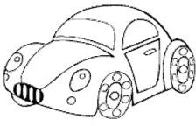Inglés. 1º Primaria Repaso Tercer Trimestre.

Nombre: ________________________________

The negative form of the verb have
I have not got You have not got. He has not got She has not got
It has not got We have not got
You have not got They have not got
I _______
You ________
He ________
She _______
It _________
We ________
You ________
They _________
_____ have not got
______ have not got
_____ has not got
_____ has not got
____ has not got
_____ have not got
_____ have not got
____ have not got
Complete with the negative form of the verb have

I____________________ two cats.

She _________ a pencil.

We_________ three dogs.

They________ a car.

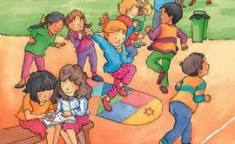Inglés. 1º Primaria Repaso Tercer Trimestre.

Nombre: ________________________________
Complete with the negative form of the verb have and translate
They friends

You a new t-shirt

She a cat.

I a dog.

He a ball.

You a flower.

She an umbrella

Inglés. 1º Primaria |  |  | Repaso Tercer Trimestre.
Nombre: ________________________________
Read, draw and colour.
Write the word
Sunny | snowy | windy | rainy  
A blue skirt. | A red boots. | A green cap.

A yellow hat. | A pink dress | A black trousers.

Inglés. 1º Primaria Repaso Tercer Trimestre.
Nombre: ________________________________
Write It is …… or It is not……
What´s it? It is not a foot.
It is a hand.

What´s it?
an eye.
a mouth.

What´s it?
a horse.
a lion.

What´s it? a cat.
a dog.
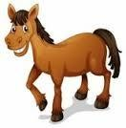
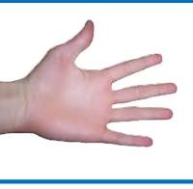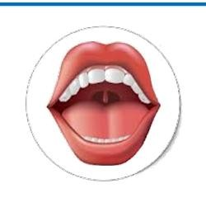

Inglés. 1º Primaria Repaso Tercer Trimestre.
Nombre: ________________________________
Write the negative form of the sentences
AFIRMATIVE | NEGATIVE
It has got a ball.
He has got two pencils.
I have got a cat.
We have got four apples.
They have got a car.
She has got two brothers.
You have got a drum.
We have got a ball.
You have got three trousers.
He has got five dog.

Inglés. 1º Primaria Repaso Tercer Trimestre. Nombre: ________________________________
To Have Got interrogative form.
 |  | Have I got? Have you got?  Has he got? |  |  | Have ?  Have ?  Has ? |  |  | _____ I got?  ______ you got?  _____ he got?
 |  | Has she got? Has it got? Have we got? Have you got? Have they got? |  |  | Has ?  Has ?  Have ?  Has ?  Have ? |  |  | _____ she got?  ____ it got?  _____ we got?  _____ you got?  ____ they got?
 |  | Complete with  ________I _______    ____ we th | the interrogativ  _ two cats?  ______she ___ a p ree dogs?  ____they ____ |  |  | e for of  encil?  a car? |  |  | the verb “have”
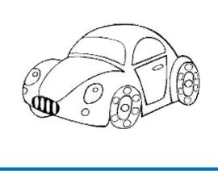

Inglés. 1º Primaria Repaso Tercer Trimestre.
Nombre: ________________________________
Write the negative and interrogative form of the sentences
 | AFIRMATIVE | NEGATIVE | INTERROGATIVE
 | It has got an apple.
 | He has got two dogs.
 | I have got a friends.
 | We have got four cats
 | They have got ten pencils.
 | She has got a car.
 | You have got a house.
 | We have got three dolls.
 | You have got a guitar.
 | He has got five t- shirts.

